
Land Information Ontario (LIO) Warehouse
Data Class Name: Recreation Point
Documentation
Produced by: Information Access and Information Management Policy Unit
Ministry of Natural Resources and Forestry
Date: July 27, 2015

Purpose

This document provides additional information to support the use of geospatial data. The Physical Model Diagram provides a visual representation of the relationships in the data class. The Data Change History lists all the modelling and access changes that have occurred during the lifecycle of the data class. A data description identifying table and field names is available upon request.

Need Assistance?
Please contact LIO Support at lio@ontario.ca or 705-755-1878 if you require help.

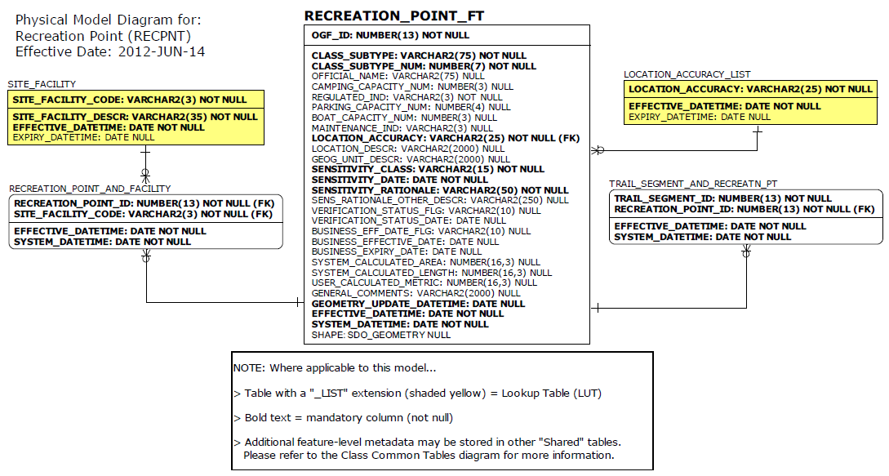

Data Class Change History

Data Class Name: Recreation Point
Data Class Short Name: RECPNT
Date  YYYY-MM-DD | Details of Change
2009-01-06 | Lookup Table values added to SITE_FACILITY.SITE_FACILITY_DESCR:  - Privy  - Tent Pad
2008 | GUT Added: Beach-  Adding a GUT called Beach to track individual beach locations.  Description:  A shore of a body of water covered by sand, gravel, or larger rock fragments.
2008 | Data Class Name changed: Recreation Point-  Name change from Recreation or Access Point to Recreation Point  Description change from:  “A Recreation Point is a point feature that identifies a site designated for recreational activities.”  To:  “A recreation point is a point feature that identifies a site used for recreational activities”
1997 | NEW Data Class
Data Description
Please refer to the metadata record for the data description.

